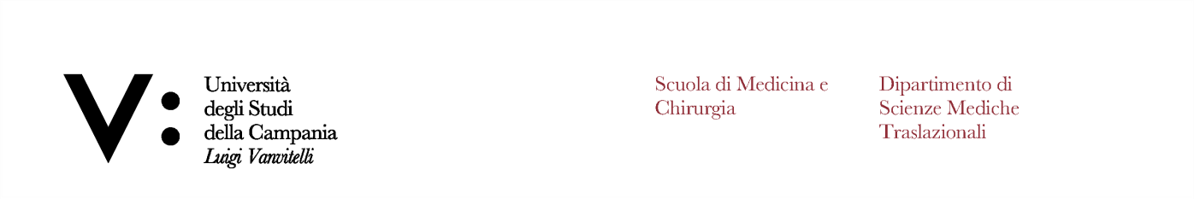

**Università degli Studi della Campania L. Vanvitelli Traslational Medical Sciences Department NURSING BACHELOR’S COURSE**

**CALENDAR OF LEARNING ACTIVITIES A.Y. 2024-2025**

**1ST YEAR 1ST SEMESTER**

|  |  |  |  |  |  |  |
| --- | --- | --- | --- | --- | --- | --- |
| **2024**  **November** | **Schedule** | **ROOM APOLLONIA**  **Mon 11** | **Tue 12** | **ROOM SP4**  **Wed 13** | **Thu 14** | **ROOM SP4**  **Fri 15** |
| 14.00/14.45 | Anatomy |  | Biology |  | Biochemistry |
| 14.45/15.30 | Anatomy |  | Biology |  | Biochemistry |
| 15.30/16.15 | Anatomy |  | Biology |  | Biochemistry |
| 16.15/17.00 | Anatomy |  | Phisiology |  | Gen Nursing |
| 17.00/17.45 | Anatomy |  | Physiology |  | Gen Nursing |
| 17.45/18.30 | Anatomy |  | Physiology |  | Gen Nursing |
|  | **Schedule** | **ROOM APOLLONIA**  **Mon 18** | **ROOM SP6**  **Tue 19** | **ROOM SP4**  **Wed 20** | **ROOM FANZAGO**  **Thu 21** | **ROOM SP4**  **Fri 22** |
| 14.00/14.45 | Biology | Phisiology | Biology | Phisiology | Biochemistry |
| 14.45/15.30 | Biology | Physiology | Biology | Physiology | Biochemistry |
| 15.30/16.15 | Biology | Physiology | Biology | Physiology | Biochemistry |
| 16.15/17.00 | Embryology | Biochemistry | Phisiology | Phisiology | Phisiology |
| 17.00/17.45 | Embryology | Biochemistry | Physiology | Physiology | Physiology |
| 17.45/18.30 | Embryology | Biochemistry | Physiology | Physiology | Physiology |

ROOM APOLLONIA E ROOM FANZAGO: ground floor Complesso Odontoiatria, via L. de Crecchio 7, Napoli

ROOM SP4: ground floor Complesso Santa Patrizia, via Luicano Arnanni 5, Napoli

ROOM SP6: second floor Complesso Santa Patrizia, via Luciano Armanni 5, Napoli.

Biochemistry (2 CFU – 30 h) - Prof. Debora Bencivenga Biology (2 CFU – 30 h) - Prof. Massimo Venditti Physics (1 CFU – 15 h) - Prof. Maria Lepore

Anatomy (3 CFU – 45 h) - Prof. Antonio Mezzogiorno Physiology (3 CFU – 45 h) – Prof. Antonietta MessinaEmbriology (1 CFU- 15 h) - Prof. Giulia Ricci General Nursing (2 CFU – 30 h) - Bando Nursing Theory (2 CFU – 30 h) - Bando Nursing Methodology (2 CFU – 30 h) - Bando

Il Coordinatore del Tirocinio

(Dott. Monica Napolitano) Il Coordinatore del CdL Nursing (Prof. Eva Lieto)