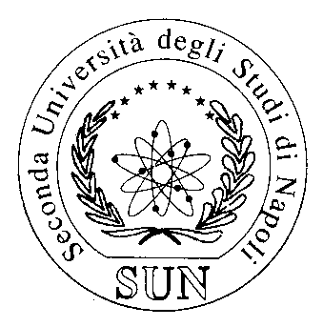
SECONDA UNIVERSITA’ DEGLI STUDI DI NAPOLI
Medicine and Surgery course in English
PROPOSAL FOR ELECTIVE DIDACTIV ACTIVITIES (ADE)
(please send to gianpaolo.papaccio@unina2.it)

Title OF E.T.A. |  | Auditory system MRI and CT anatomy and Pathology
Teacher |  | RENATA CONFORTI
Specific Objectives  (max 500 characters) |  | To know indication and prespective of temporal bone diagnostic problems
ACTIVITY TYPE | check | Hours |  | CFU
Practical/LAB | □ | 25 |  | 1
Interactive seminar | x□ | > 10 up to 15 | ________ | 1
Interactive seminar | □ | > 5 up to 10 | ________ | 0,5

- Year period | 2017-2018
- maximum n. of students | 8
- Year/semester | II SEMESTRE
- PRIOR KNOWLEDGE REQUESTED | RADIOLOGY
- LOCATION | CTO Viale Colli Aminei 21 Napoli
- FIXED DATES/DAYS | 20 APRILE 2018

